**EXERCISE 3**

**Objective:** The objectives include:

* inserting, displaying, updating, deleting data from MySQL db.
* learning the SQL JOIN functions, Views, and indexing

**You may use SQLite or MySQL DBMS**.

1. Create two relations/tables. Each table must have a minimum of three attributes.

Example:

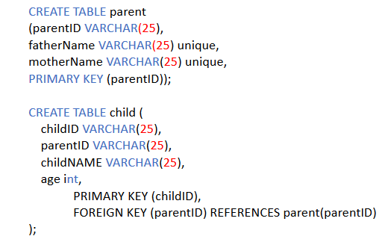

1. Populate the tables with sample data.
2. Execute each of the following SQL commands. What different think you see from each output. Get the screenshot for each.

* SELECT * FROM table1, table2;
* SELECT * FROM table1 INNER JOIN table2 ON table1.id1 = table2.id1;
* SELECT * FROM table1 LEFT JOIN table2 ON table1.id1 = table2.id1;
* SELECT * FROM table1 RIGHT JOIN table2 ON table1.id1= table2.id1;
* SELECT * FROM table1 LEFT JOIN table2 USING (id1);

1. Create a parent and children table and populate with different parents and children data. Write a query to display all the children from table1 that have common parent, where the parent id is = ‘p1’
2. Write a query to create parent_child view that selects fatherName, motherName from the parent table and childName from child table.
3. Drop parent_child view, then Write the same query to create parent_child view that selects fatherName, motherName from the parent table and childName from child table but shows the child name as a preferred name.
4. Write a query to update the parent 2 (parentID = ‘P2’) information from parent table.
5. Write a query to update the parent 3 (parentID = ‘P3’) information from parent table changing fatherName to ’John’ and mother Name to ‘Megan’.
6. Write a query to create an index that uses parentID as index key
7. Write a query that displays a row of p2 using the index created on step 9